**Effect of Swelling on Multiple Energy Transfer in Conjugated Polymer Nanoparticles**

Louis C. Groff, Yifei Jiang, Xiaoli Wang, and Jason D. McNeill

**KEYWORDS**

Diffusion, Exciton Transport, Decay Kinetics, Anisotropy

**ABSTRACT**

Many key processes in conjugated polymers are strongly influenced by multiple energy transfer (i.e., exciton diffusion). We investigated the effect of solvent-induced swelling on the kinetics of multiple energy transfer in nanoparticles of the conjugated polymers PFBT and MEH-PPV. Multiple energy transfer between equivalent chromophores results in loss of fluorescence polarization, which can be observed in the fluorescence anisotropy decay kinetics. Additionally, multiple energy transfer affects the rate of quenching by defects. We found that the rate of energy transfer between chromophores is highly sensitive to solvent effects, occurring at a rate of 1.1109 s-1, and 3.3109 s-1 for PFBT and MEH-PPV dissolved in THF, respectively, and at rates 10-60 times higher in both moderately swelled and aqueous nanoparticle suspensions. A discrete cubic lattice model incorporating distance-dependent multiple energy transfer and quenching by defects was employed to elucidate the relationships between solvent-induced swelling, fluorescence quantum yield, and decay kinetics. The simulation results show good agreement with experimental results at low to moderate THF concentrations. The results support quenching by defects or polarons, amplified by multiple energy transfer, as a likely explanation for the typically low fluorescence quantum yield of conjugated polymer particles as compared to the free polymer in solution as well as similar effects observed in thin films.



**INTRODUCTION**

Conjugated polymers (CPs) are a versatile class of semiconducting luminescent materials, used as active materials in organic photovoltaics and light-emitting diodes.{Dennler, 2005 #10;Yim, 2008 #56}{Cao, 1999 #192} Conjugated polymer nanoparticles (CPNs) are well-suited to a variety of fluorescence-based imaging and sensing applications, exhibiting extraordinary figures of merit, including exceptional brightness and photostability.{Wu, 2008 #51}{Wang, 2013 #61} Furthermore, highly efficient energy transfer to dyes or other polymers incorporated in the particle or to dyes covalently linked to the surface can provide red-shifted emission and sensors.{Wu, 2006 #48}{Groff, 2013 #60}{Wang, 2013 #61}{Chan, 2011 #80} To tune CPN properties for various applications, we seek to better understand the species and processes that dictate their properties, and how they are modulated by polymer conformation and processing conditions.{Schaller, 2002 #98}{Wu, 2008 #99} The complex, nanoscale, multichromophoric nature of CPNs can give rise to a number of transient and persistent species interacting with the excited state including H- or J-aggregates, excimers, and exciplexes.{Nguyen, 1999 #96}{Jenekhe, 1994 #183}{Wurthner, 2011 #140} Furthermore, chemical defects, excess charges (i.e. hole polarons), and incorporated dyes can have significant effects on fluorescence properties.{Hintschich, 2003 #19}{Yu, 2004 #171}{Lyons, 2005 #28}{Wu, 2008 #49}{Yu, 2012 #58} In addition, energy transfer between like conjugated polymer chromophores (i.e., exciton diffusion) can result in a cascade of multiple energy transfer events, greatly amplifying the effects of these species.{Scholes, 2006 #36}{Kasha, 1963 #186}{Mikhnenko, 2015 #195} Recently, we showed that multiple energy transfer in CPNs gives rise to characteristic complex fluorescence kinetics.{Groff, 2013 #60}

Here, we investigate the effects of solvent-induced swelling on the excited state dynamics in CPNs, using steady-state and time-resolved fluorescence spectroscopy to develop and test a multiple energy transfer model and thus gain a clearer picture of the interplay of the various species and processes that determine the optical properties and excited state dynamics of CPNs. We previously employed a similar approach to determine the length scale of exciton diffusion in dye-doped CPNs.{Groff, 2013 #60} Particle swelling increases the inter-chromophore distance, causing a reduction in the rate of multiple energy transfer and thus a reduction in the quenching efficiency and an increase in the excited state lifetime. By fitting parameters of a multiple energy transfer model to picosecond fluorescence anisotropy decay results, we obtain an approximate picture of the characteristic length scale and time scale of energy transfer between pairs of like chromophores (homo-transfer) as well as how the energy transfer cascade is modulated by swelling. The agreement with model predictions over a broad range of swelling supports the proposed multiple energy transfer picture. The comparison of results from two different polymers suggests that higher rates of homo-transfer, which is sometimes desired (e.g., to improve exciton transport in photovoltaics, or for some sensor schemes) comes at the price of reduced fluorescence quantum yield due to increased quenching by defects. This provides a possible explanation for the large reduction in fluorescence quantum yield often observed for some conjugated polymer films and particles as compared to the free polymer in solution. On the basis of this picture, we suggest that in some cases, the optical properties CP films and particles can be improved by interfering with the multiple energy transfer cascade, either by competitive energy transfer or by increasing interchromophore spacing.

**EXPERIMENTAL METHODS**

**Materials.** The copolymer poly[(9,9-dioctylfluorenyl-2,7-diyl)-*co*-(1,4-benzo-{2,1',3}-thiadiazole)] (PFBT, MW 10,000, polydispersity 1.7), and the poly(phenylene vinylene) derivative poly[2-methoxy-5-(2-ethylhexyloxy)-1,4-phenylenevinylene] (MEH-PPV, MW 200,000, polydispersity, 4.0) were purchased from ADS Dyes, Inc. (Quebec, Canada). The fluorescent dye fluorescein was purchased from Life Technologies (Invitrogen, Grand Island, NY). The fluorescent dye Lucifer Yellow CH dipotassium salt (LY, 1 mg/mL in water), solvent tetrahydrofuran (THF, anhydrous, inhibitor-free, 99.9%) and sodium hydroxide (SigmaUltra, minimum 98%) were purchased from Sigma-Aldrich (Milwaukee, WI). All materials were used as provided without further purification.

**Nanoparticle Preparation.** The preparation of fluorescent nanoparticles was performed via a previously described nano-precipitation method.{Szymanski, 2005 #42} The conjugated polymers PFBT and MEH-PPV were dissolved in THF by gentle agitation and prepared at a concentration of 1000 ppm. An aliquot of each stock solution was used to prepare precursor solutions at 20 ppm. A 2 mL quantity of a given precursor solution was rapidly added into 8 mL of deionized water under bath sonication at a frequency of 40 kHz and room temperature. Removal of THF was accomplished by the following procedure. Nanoparticle suspensions were placed in a vacuum oven under nitrogen flow for 8 hours at room temperature in order to remove enough THF to prevent bumping during the subsequent vacuum evaporation step. Nitrogen flow was ceased and samples were evaporated under vacuum in a vacuum oven at room temperature using a two-stage rotary vane pump with a base pressure of ~10 torr. The samples were heated at ~40 °C for 6-7 hours to remove most of the remaining THF. The total volume of liquid was typically reduced by 60% during the vacuum evaporation process. A Raoult’s Law calculation indicates that <1% THF remains in solution at ~40% volume loss. No residual THF odor was detected in the aqueous samples. Also, at this point, further evaporation yielded no change in the fluorescence spectrum or quantum yield. We validated this process further by assessing the batch-to-batch reproducibility of the fluorescence spectra, and fluorescence quantum yield of the aqueous nanoparticle samples. Four batches of nanoparticles were prepared using each polymer. The nanoparticle fluorescence spectra were identical in shape and peak emission wavelength for both polymers. The fluorescence quantum yield varied between 4%-6% for PFBT CPNs, and remained constant at ~1% for MEH-PPV CPNs. The aqueous samples were vacuum filtered through a glass fiber prefilter to remove larger aggregates and a 0.1 µm PVDF membrane filter (Millipore). The fraction of polymer lost in the filtration process was typically ~10%, as measured by UV-vis. The resulting suspensions are clear (not turbid) and stable for months with no visible signs of aggregation.

**Swelling Procedure.** In addition to nanoparticles in water and polymer in THF, swelled nanoparticle samples were prepared by diluting an aliquot of concentrated nanoparticle suspension with the appropriate volume of water, followed by slowly adding THF to produce 3 mL of suspensions with volume ratios of THF/water between 0.2 and 0.95. Each sample was gently agitated to ensure solution homogeneity. The sample absorbance was kept at or under ~0.05 (~0.02 for 95% THF). Samples were capped and the headspace purged with nitrogen in order to limit quenching and photobleaching by O2 (purging was limited to ~2 minutes, in order to limit loss of THF).

**Characterization Methods.** UV-Vis absorption spectra were acquired using a Shimadzu UV2101PC scanning spectrophotometer with 1 cm quartz cuvettes. Fluorescence spectra and fluorescence quantum yield were measured with a commercial fluorimeter (Quantamaster, Photon Technology International) using 1 cm quartz cuvettes. The size distributions and morphologies of the aqueous nanoparticle samples were measured using atomic force microscopy (AFM). Each sample was prepared on a cleaned glass coverslip via immersion casting in a dilute sample of CPNs for 40 minutes followed by drying overnight in an enclosed environment. The surface topography was measured on an Ambios Q250 multimode AFM in AC mode with a lateral resolution of 10 nm. Particle diameters were measured via analysis of particle heights.

Picosecond fluorescence lifetimes and fluorescence anisotropy decay (FAD) were measured under nitrogen using a home-built setup for time-correlated single photon counting (TCSPC) spectroscopy operating in reverse mode. Frequency doubled pulses (420 nm) from a passively mode-locked Ti:Sapphire laser (Coherent Mira 900, 840 nm pulses, ~150 fs pulsewidth) were used as the excitation source for the nanoparticle samples. Fluorescence was collected perpendicular to the excitation source and passed through a 460 nm long pass filter, and a calcite Glan-Taylor polarizer (Thorlabs, GT10-A) oriented either parallel (0°), perpendicular (90°), or at magic angle (55°) with respect to to the vertically polarized excitation. All three polarization angles were utilized for anisotropy decay measurements, and magic angle polarizer orientation was adopted for excited state population decay measurements. The output of a single photon avalanche photodiode (APD, id Quantique, id100-50) was used as the start timing pulse for a time-to-amplitude converter (TAC, Canberra Model 2145), and the output of a fast PIN diode (Thorlabs, DET210) was used as the stop pulse, in a standard reverse-mode configuration.{Schaffer, 1999 #88}{Cross, 1984 #87} The excitation power was attenuated (between ~300 µW and 1 mW, typ.) to maintain a count rate of ~400 kHz as measured at the APD. The analog TAC output was digitized using a multi-channel analyzer (FastComTec, MCA-3A). Before and after each measurement an instrument response function (IRF) was measured using scattered excitation light from a dilute suspension of polystyrene microspheres. The width of the IRF was determined to be ~70 ps (fwhm). Typical peak signal-to-noise ratios (SNR) for each run were between 200:1 (80%-100% THF samples) and 500:1 (IRF and low-mid % THF samples). The reported information was collated from a total of two samples per concentration of THF, and 3-5 runs per sample. Intensity decays were collected for 5-20 minutes each to obtain the above mentioned SNR values, depending on the lifetime of the sample.

**RESULTS/DISCUSSION**

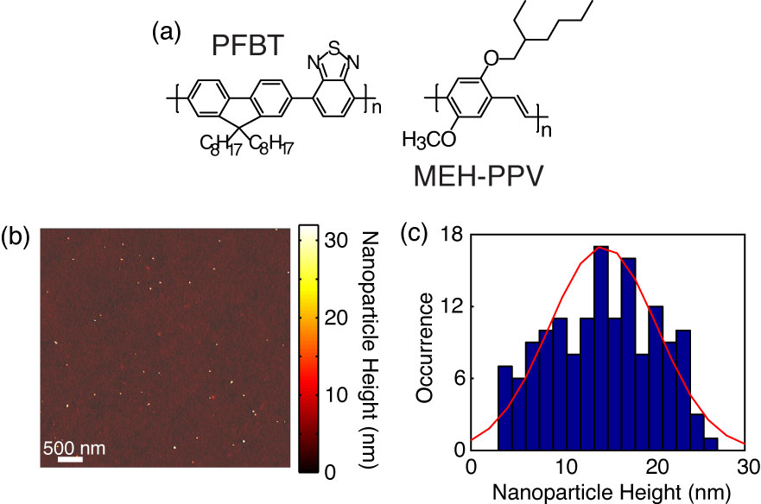

**Fig 1.** (a) Chemical structures of PFBT and MEH-PPV. (b, c) Representative AFM image of PFBT CPNs with particle height histogram.

**Characterization of PFBT and MEH-PPV CPNs.**  PFBT and MEH-PPV nanoparticles were prepared via a nano-precipitation method described previously.{Szymanski, 2005 #42} The chemical structures of PFBT and MEH-PPV are given in Fig. 1. Nanoparticle size distributions were determined via particle height analysis of several AFM images, and each histogram was constructed using >100 particles (c.f. Fig. 1). The mean particle sizes were 14 ± 6 nm for PFBT CPNs and 9 ± 5 nm for MEH-PPV CPNs, which are consistent with previous measurements.{Wang, 2013 #61}

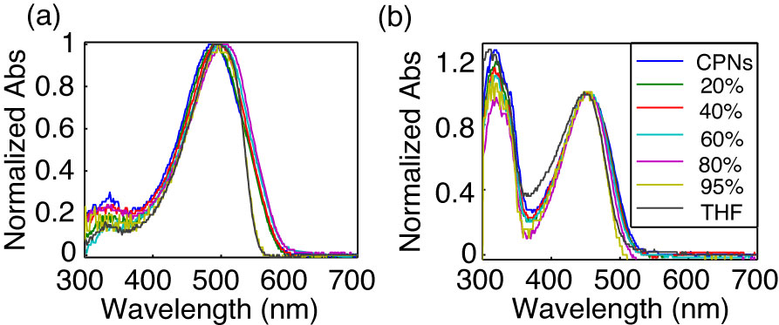

**Fig. 2.** Normalized absorption spectra of (a) MEH-PPV and (b) PFBT at varying volume % THF.

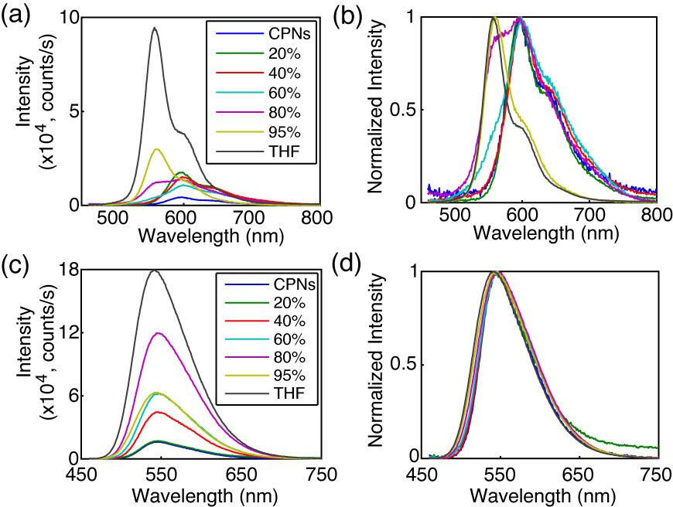

**Fig. 3.** (a,c) Absolute and (b,d) normalized emission spectra of MEH-PPV (top) and PFBT (bottom) at varying volume % THF.

**Effect of solvent composition on UV-vis and fluorescence.** The UV-Vis and fluorescence spectra of PFBT and MEH-PPV as a function of solvent composition are given in Figs. 2 and 3. The absorption spectra of PFBT maintain a similar shape with increasing THF, with a ~5 nm total blue shift, and slight broadening of the sample spectrum in 100% THF. The emission spectra show a monotonic increase in fluorescence intensity with increasing THF, and the spectra also exhibit a blue shift ~5 nm with increasing THF. The absorption spectra of MEH-PPV maintain a similar shape as THF concentration is increased, though the 95%-100% THF spectra are narrower than the spectra of the other samples. The absorption peak of MEH-PPV red shifts a total of ~15 nm from 0%-80% THF, and then blue shifts ~7 nm for the 95%-100% THF samples. The emission peak blue shifts a total of ~40 nm as THF composition is increased, and it appears that from ~40% THF to 80% THF there are possibly two phases present in solution based on the increase in intensity of the ~560 nm shoulder on the spectrum, and the reduction in intensity of the ~600 nm shoulder of the spectrum, which correspond to isolated polymer chains and aggregate species, respectively as % THF increases. An approximate isosbestic point can be seen at ~580 nm over the concentration range of ~60%-80% THF.

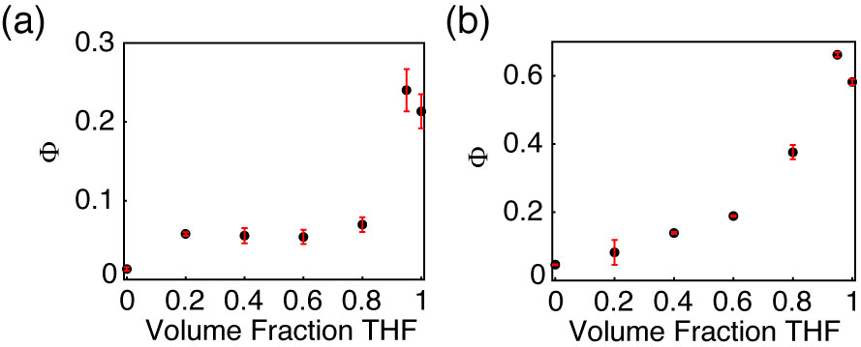

**Fig. 4.** Fluorescence quantum yield vs. THF volume fraction for (a) MEH-PPV and (b) PFBT.

The fluorescence quantum yields ( are given in Fig. 4. The quantum yield of PFBT increases monotonically with increasing THF. However, MEH-PPV shows an initial intensity increase from 0%-20% THF, followed by the quantum yield staying relatively consistent from 20% to 80% THF, then increasing at higher % THF. The ~12% difference in quantum yield between the CPN samples in 95% THF and the dissolved polymers in THF is likely a statistical anomaly due to the uncertainty in the absorbance. While the fluorescence quantum yield remains relatively constant for MEH-PPV from 20% to 80% THF, the relative contribution of the ~600 nm shoulder decreases steadily with increasing THF concentration, likely indicating that this feature is associated with aggregate species.

One possible interpretation of the results outlined in Figs. 3 and 4 is that the coupling between transition dipoles is somewhat stronger for MEH-PPV as compared to PFBT. This is supported by the steady-state spectra, which exhibit a pronounced red-shift (in both absorption and emission) for MEH-PPV, while PFBT exhibits much smaller shifts. The lesser red shift in the absorption spectra of MEH-PPV as compared to the emission can be explained by a small fraction of highly red-shifted J-aggregate species. This is consistent with the two-state picture of Barbara, et al., used to discuss the bimodal emission properties in single molecule spectra of both PFBT and MEH-PPV. In this picture, there is a minority aggregate state that exhibits weak, red-shifted emission, and acts as an energy acceptor to the other (unaggregated) chromophores.{Yu, 2000 #113}{Yip, 1998 #110}{Grey, 2006 #102}{Lee, 2006 #105}{Kim, 2006 #108} In the case of swelling, it is likely that swelling either disrupts aggregate formation, or that it reduces the rate of energy transfer to aggregate species, or both.

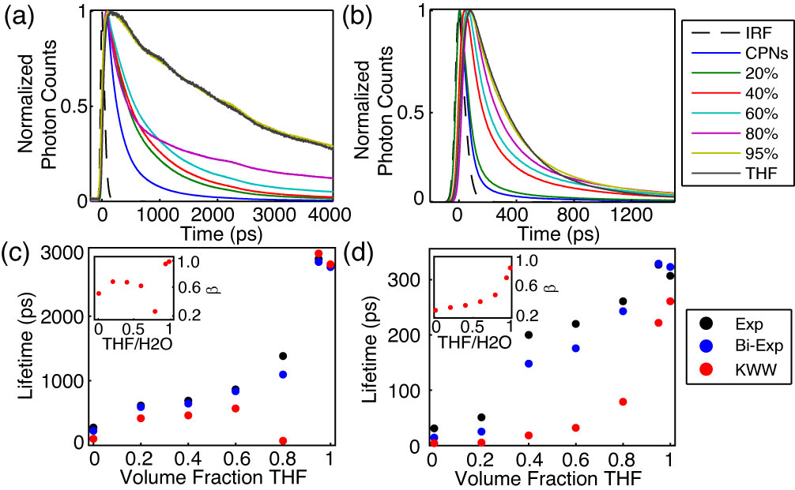

**Fig. 5.** (a,b) Normalized fluorescence intensity decays, and (c,d) lifetimes resulting from single exponential, bi-exponential weighted average, and KWW trial functions with stretch parameter ** insets) versus THF volume fraction for PFBT and MEH-PPV, respectively.

**Table 1.** Summary of results of bi-exponential least-squares fitting to time-resolved fluorescence of MEH-PPV and PFBT CPNs, including weighted amplitudes (***A1***, ***A2***) and individual exponential time constants (***1*********).

|  |  |  |  |  |  |  |  |  |
| --- | --- | --- | --- | --- | --- | --- | --- | --- |
| **Volume Fraction THF** | **MEH-PPV** | | | | **PFBT** | | | |
| ***A1*** | ***1* (ps)** | ***A2*** | ***2* (ps)** | ***A1*** | ***1* (ps)** | ***A2*** | ***2* (ps)** |
| **0** | 0.96 | 9 | 0.04 | 150 | 0.59 | 88 | 0.41 | 420 |
| **0.20** | 0.93 | 14 | 0.07 | 180 | 0.51 | 260 | 0.49 | 940 |
| **0.40** | 0.73 | 56 | 0.27 | 400 | 0.51 | 280 | 0.49 | 1000 |
| **0.60** | 0.75 | 74 | 0.25 | 480 | 0.55 | 360 | 0.45 | 1400 |
| **0.80** | 0.75 | 120 | 0.25 | 620 | 0.65 | 230 | 0.35 | 2700 |
| **0.95** | 0.80 | 220 | 0.20 | 760 | 0.02 | 230 | 0.98 | 2900 |
| **1** | 0.95 | 270 | 0.05 | 1300 | 0.01 | 270 | 0.99 | 2800 |

**Picosecond Time-Resolved Fluorescence Spectroscopy.** TCSPC obtained at magic angle to the excitation source was employed to measure the excited state decay kinetics of both CPN systems over the range of solvent composition. The trial functions employed during iterative reconvolution fitting analysis were single exponential, bi-exponential, and the Kolrausch-Williams-Watts (KWW) function or stretched exponential, given by , where ** is the stretch parameter. Values for ** are typically between ~0.3 and 1, where lower values correspond to a broader distribution of lifetimes, and **   corresponds to a single exponential lifetime.{Chen, 2003 #8} The fits to all three trial functions converged for all samples. With exception of PFBT in THF, which was fit best by a single exponential, the remaining intensity decays fit poorly to a single exponential, with the residuals showing systematic deviation consistent with bi-exponential or multi-exponential dynamics. The representative intensity decays for each sample, along with the respective time constants and **versus THF volume fractionare given in Fig. 5. The lifetimes for both systems follow a monotonically increasing trend as THF concentration increases. The lifetimes of the CPN samples in water are shorter than previously reported (~270 ps versus ~700 ps previously for PFBT), which can be ascribed to a more complete THF removal. This explanation is also consistent with the reduced quantum yield ( = 0.04 versus  = 0.14 previously for PFBT CPNs).{Groff, 2013 #60} ** increases for both systems as the fraction of THF increases, beginning at ~0.3 for MEH-PPV in water and increasing monotonically to ~0.8 for MEH-PPV in THF, indicating an overall decrease in lifetime heterogeneity, though even in good solvent there is some heterogeneity. Similarly, ** for PFBT increases monotonically from ~0.6 for CPNs in water to unity in THF. A substantial decrease in* * is observed for PFBT from ~0.7 at 60% THF to ~0.3 at 80% THF, and is indicative of a dramatic increase in the distribution of exciton lifetimes. This deviation from the trend of increasing ** as % THF increases is hypothesized to be due to the presence of two distinct emitting populations with substantially different lifetimes at moderately high % THF, discussed further below. The overall trend of increasing ** for both polymers is assumed to result from increases in equilibrium chromophore spacing as THF concentration increases, leading to the reduction of the rates of multiple energy transfer to quenchers. This picture is supported by prior results of dye-doped CPNs, where a reduction in ** was observed as additional quenchers (dyes) were introduced.{Groff, 2013 #60} The results of the bi-exponential least-squares fitting analysis are discussed in greater detail below.



A summary of the bi-exponential least-squares fitting results is given in Table 1. For MEH-PPV, the larger time constant increases monotonically with increasing THF fraction, and the weighted amplitudes do not change appreciably except for MEH-PPV in 100% THF where lifetime is characterized almost entirely by the short time constant. In contrast, the time constants remain approximately the same for PFBT between 80-100%, and the weighted amplitude corresponding to the long time constant increases from 80-100% THF. Thus, the lifetime results perhaps suggest a two state-like equilibrium, in which swelled nanoparticles and isolated polymer chains coexist in equilibrium, within a narrow range of THF concentrations. This hypothesis is further supported by the anomalously low ** observed for PFBT in 80% THF and is discussed in more detail below.

Given the red-shifting of fluorescence emission in CPNs, it is assumed that chain collapse into nanoparticles introduces J-aggregate species. J-aggregation is typically accompanied by an increase in radiative rate due to an increase in the net transition dipole moment.{Jelly, 1936 #21}{Wurthner, 2011 #140} With this in mind, the radiative rate of a given polymer or CPN sample was calculated using the fluorescence quantum yield and fluorescence lifetime by . While the uncertainty was too high to observe a clear trend, the radiative rate varied over a factor of ~2 for PFBT (~1.2×108 s-1 to 2.5×108 s-1) and a factor of ~4 (~3.0×108 s-1 to 1.2×109 s-1) for MEH-PPV over the range of THF concentration, indicating that transition dipole coupling between like chromophores is possibly stronger in MEH-PPV as compared to PFBT.

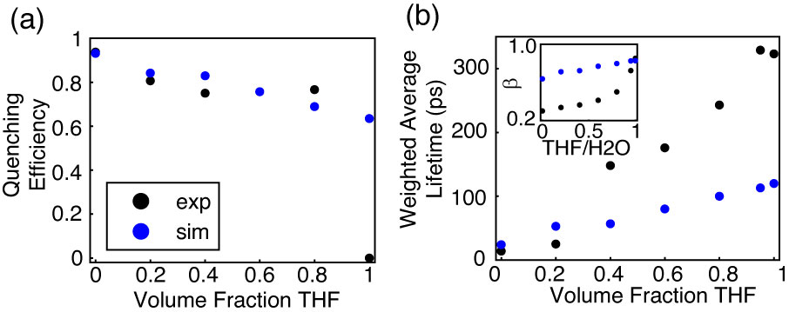

**Fig. 6.** Comparison of simulated (blue) and experimental (black) (a) quenching efficiency, (b) average lifetime, and (inset) KWW stretch parameter *ß* versus THF volume fraction for MEH-PPV.

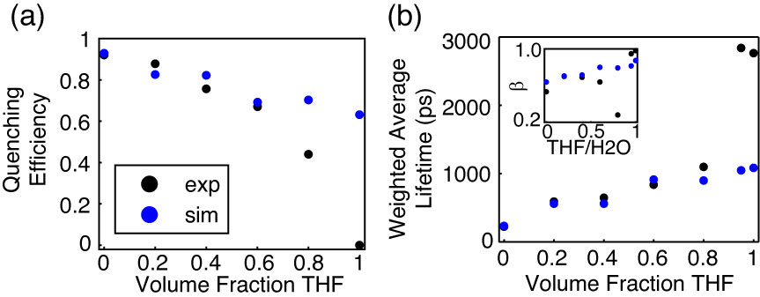

**Fig. 7.** Comparison of simulated (blue) and experimental (black) (a) quenching efficiency, (b) average lifetime, and (inset) KWW stretch parameter *ß* versus THF volume fraction for PFBT.

**Lattice Swelling Model.** In a dense, multichromophoric system, (incoherent) exciton transport can be described as a series of energy transfer steps to roughly equivalent neighboring chromophores, terminated by a quencher (e.g. a nonfluorescent chemical defect or red-shifted, weakly fluorescent aggregate), or radiative or non-radiative relaxation to the ground electronic state. The rate of multiple energy transfer depends on the interchromophore spacing, which is determined by the amount of swelling in the CPNs (i.e. by the solvent composition). We hypothesize that the multiple energy transfer rate is increased at low THF concentrations due to increased chromophore density. This results in increased quenching and faster decay kinetics in aqueous CPN suspensions compared to the polymers in good solvent. To test this picture, we have employed a discrete lattice approach using a numerical random walk algorithm in order to model the effect of solvent-induced swelling on exciton quenching and decay kinetics. Similar approaches were previously utilized to model exciton diffusion and energy transfer in dye-doped nanoparticles on a discrete cubic lattice, and to model fluorescence centroid fluctuations due to polaron motion on single CPNs. {Wu, 2008 #49}{Yu, 2012 #58} Here, we represent the particle as a cubic lattice. Each lattice point represents one chromophore, with lattice spacing (*x*) determined by the approximate volume of one chromophore by . Each chromophore is assumed to consist of two monomer units, resulting in chromophore sizes of 0.9 nm for MEH-PPV CPNs and 1.2 nm for PFBT CPNs. Excitons undergo energy transfer between nearest neighbor chromophores, and the energy transfer rate is set to reproduce the observed exciton diffusion length from previous work of *LD* = 12 nm, which is assumed for both polymers.{Groff, 2013 #60} The multiple energy transfer probability for a random walk in the absence of swelling is given by, where *t* is the time step, and *D* is the exciton diffusion constant given by , where is the lifetime of the polymer in the absence of quenchers.



In order to account for solvent-induced swelling, we assume that swelling occurs in a similar fashion to other structurally similar polymers such as polystyrene (PS). As such, increases in the lattice spacing were calculated using particle sizing results obtained by Carson, et al. via optical microscopy on PS beads swelled with THF.{Lee, 2011 #59} A swelling factor, which accounts for increases in nanoparticle size as THF concentration increases, is given by, where *V*0 is the nanoparticle volume in water and *V* is the swelled nanoparticle volume. This ratio varies between 0 and 1 where *f* = 1 corresponds to a close-packed nanoparticle or film, and 0 represents “infinite” swelling. Assuming spherical particles, , where the subscripts indicate nanoparticle radius and swelled particle radius, respectively. With the assumption that swelling increases grid spacing, the swelled lattice spacing becomes *d*, defined as . The increase in the interchromophore distance due to swelling is calculated by scaling the interchromophore spacing to match the PS/THF swelling results. The model quenching efficiency and ** are relatively insensitive to the initial chromophore spacing (tested using 0.8 nm and 1.5 nm lattice spacing, holding all other parameters constant). The model exciton lifetime is the most sensitive to changes in lattice spacing, yielding a 20% difference in lifetime for particles with initial lattice spacing between 0.8–1.5 nm. These differences are accounted for by scaling the energy transfer rate to reproduce *LD*.

Based on the well-known result that transition dipole coupling strength in excitonic systems is proportional to the interchromophore distance raised to a power -*k*, which is a constant typically between 2-4, assumed to be 2 for these (or similar) polymers,{Emelianova, 2010 #14} the multiple energy transfer probability was reduced by an adjusted swelling factor. Multiplying this factor by the initial energy transfer probability gives . The time step size was adjusted so that prior to increasing the interchromophore spacing, the energy transfer probability was between 1-2%. An integer number of quenchers are placed randomly on the lattice, each with a Förster-type quenching radius of 4 nm, similar to that of a perylene red dye molecule.{Groff, 2013 #60} The mean number of quenchers per nanoparticle is determined by adding quenchers until the simulated exciton lifetime approximately reproduces the lifetime of CPNs in water. The grid spacing of the lattice was calculated for a 10x10x10 nm cubic particle, with the number of grid points given by , where *dnp* is the particle diameter, resulting in 1331 grid points for MEH-PPV and 512 grid points for PFBT, in the absence of swelling. The mean number of quenchers for each polymer was determined to be 9 for PFBT, and 10 for MEH-PPV. The greater number of quenchers per CPN than those previously reported for dye-doped PFBT CPNs (2.2 per CPN) can be ascribed to several differences, including the use of a discrete lattice model with fixed step sizes as opposed to a continuum model with random step sizes, and a larger particle was assumed in this model. In addition, the Poisson distribution of quenchers has not been accounted for this model, which results in somewhat higher values for ** than previously reported. The exclusion of Poisson statistical effects on the system is due to the quality of fit of the model results to the experimental results in its absence (discussed below), and was discussed in detail in our previous work on dye-doped PFBT CPNs.{Groff, 2013 #60}



At low to moderate THF concentrations, the model results match well to experimental intensity decay kinetics and quenching efficiency, the latter given by , where *s* and *poly* are the fluorescence quantum yields of the sample and the polymer in THF, respectively. The simulated quenching efficiency matches the experiment well up to 60% THF for PFBT, and up to 80% THF for MEH-PPV (c.f. Fig. 6). The time constants obtained from the simulated intensity decays match experimental TCSPC fitting results well up to 20% THF for MEH-PPV and up to 80% THF for PFBT. With exception of CPNs in 80% THF,* * is reproduced relatively well for PFBT. However, ** is not reproduced very well for MEH-PPV, except for MEH-PPV in THF (c.f. Fig. 7). The observed divergence between simulation and experiment outside of the aforementioned solvent compositions corresponds to the regions of moderate THF composition, where it is speculated that the polymer is in dynamic equilibrium between an aggregate and free polymer state, particularly between 40%-80% THF for MEH-PPV and 80% THF for PFBT. The poor agreement with experimental ** values for MEH-PPV is hypothesized to be due to the exclusion of correlated chromophore orientations and the Poisson distribution of quenchers in this model. Additionally, emission from a longer-lived state with charge transfer character or a partially oxidized species could be contributing to the complexity of the fluorescence decay.{Jenekhe, 1994 #183}{Yan, 1994 #209}{Yan, 1995 #208}{Papadimitrakopoulos, 1994 #210}



In this and previous work, it has been hypothesized that the reduced quantum yield, reduced fluorescence lifetime, and heterogeneous dynamics of CPNs relative to polymer in good solvent arises from quenching by chemical defects and/or photogenerated hole polarons.{Groff, 2013 #60} With the assumption that multiple energy transfer is a FRET-mediated process, it follows that the energy transfer efficiency to defect sites would depend upon the number of nearest neighbor chromophores, which is related to the dimensionality of the system. As an alternate perspective to the above lattice model calculations, the effect of dimensionality on quenching efficiency was investigated (using the PFBT parameters), by determining how quenching efficiency differs in isolated, one-dimensional chains of chromophores versus a 3D spherical particle.

The information for a spherical particle is taken from the above experimental and simulated data for PFBT, in which the particle is assumed to be 10 nm in diameter, with quenching efficiency ~92%. The quenching radius *Rq* is taken from the simulations at 4 nm. For the one dimensional case, an ensemble of linear chains is assumed, and the approximate integer number of chains per CPN (*Nchain*) is calculated from the relevant information for a spherical particle. The contour length of each chain is given by , where *Lchrom* is the 1D length of one chromophore (assuming C-C bond lengths similar to benzene, yields ~2.5 nm/chromophore), and *Nchrom* is the number of chromophores per chain. A number of Poisson distributed quenchers *Nq* are assumed whose quenching radii do not overlap. The total quenched contour length is calculated by



, (1)



where the index *n* corresponds to the number of quenchers, and *Nn* is the number of chains in the ensemble containing *n* quenchers, and the quenching efficiency * * is calculated by

. (2)



Equation 2 results in ~11% quenching efficiency for a one dimensional ensemble of PFBT chains, which supports the notion that even with the same quantity of quenchers in the system, quenching is greatly suppressed as the nanoparticle dissociates into free chains in solution. This also supports one assumption of our quenching picture for CPNs: that quenching by defects is greatly reduced in isolated, extended chains due to a reduction in the rate of multiple energy transfer, which stems from the reduced number of nearest neighbor chromophores available for energy transfer in the 1D case, compared to the 3D case (two neighbors in 1D, versus six neighbors in 3D). This is further supported by previous modeling of linear polyenes by Beljonne et al., which shows that interchain exciton coupling weakens with increasing intermolecular separation, and as the chain length becomes larger than the intermolecular separation. In addition, it is shown that the magnitude of the intrachain transition dipole is increased with increasing chain length.{Beljonne, 2000 #211} Thus, as a particle swells and collapsed chains unfold, the excitonic coupling to interchain nearest neighbors is decreased, disfavoring 2D or 3D exciton transport, and the coupling to intrachain nearest neighbors increases, which favors 1D exciton transport.

Throughout these experiments, there have been multiple results which suggest that solvent-induced swelling can result in a two-state system at moderate THF concentrations. The observed quenching of the polymer fluorescence in the aqueous solution can be ascribed to a weakly fluorescent, red-shifted minority of aggregate choromophores that act as energy acceptors for both PFBT and MEH-PPV.{Grey, 2006 #102}{Lee, 2006 #105}{Kim, 2006 #108} Steady-state fluorescence results show a significantly blue-shifted shoulder in the emission spectrum of MEH-PPV at moderate THF concentrations, which approximately matches the spectrum of the solvated polymer, and can be ascribed to the separation of aggregate chromophores in swelled CPNs. Additionally, bi-exponential lifetime analysis results for both polymers at moderate THF concentrations yield short time constants similar to the CPNs in water, and long time constants similar to the free polymer in THF. These time constants hold fixed for PFBT from 80% to 95% THF, only shifting in the relative percent of each, as is observed in the weighted amplitudes (c.f. Table 1). The model results also significantly deviate from what is observed experimentally in the region of THF concentration where these phenomena are observed, which suggests that the lattice swelling picture alone is insufficient to describe the physics of the CPNs for moderate to high THF compositions, and it is likely that incorporating nanoparticle dissociation would result in better agreement. While it is beyond the scope of this article to determine whether the system is indeed in a two-state system, the possibility should not be ignored. For now, it can only be speculated that perhaps the system exists as both isolated polymer chains and swelled nanoparticles coexisting in equilibrium, only within a fairly narrow range of THF concentrations.

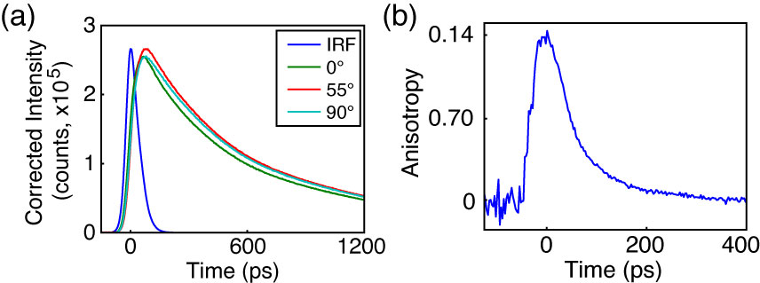

**Fig. 8.** Anisotropy data for PFBT in 40% THF. (a) Intensity decays collected at 0° (green), 55° (red), and 90° (cyan) polarizer orientations with sample IRF (blue). (b) Anisotropy decay *R*(*t*) constructed from intensity data in (a).

**Picosecond Fluorescence Anisotropy Decay (FAD).** Time-resolved anisotropy measurements provide a means to probe energy homo-transfer rates in CPNs, given the assumption that each energy transfer event prior to radiative decay slightly alters the polarization state of the exciton, leading to depolarization of the observed fluorescence photons. Fluorescence intensity decays collected at 0°, 90°, and 55° polarizer orientations relative to the vertically polarized excitation pulse were obtained via TCSPC (c.f. Fig. 8a). The resulting intensity decays were utilized to construct time-resolved anisotropy decays by the relation , where , . The process by which the anisotropy data is calculated from the fluorescence intensity decays at each polarizer orientation was adapted from a method by Fleming et al. and is described in detail in the Supporting Information.{Cross, 1984 #87} Briefly, after least-squares fitting to each intensity decay, the limiting anisotropy is determined from the corrected amplitudes of the intensity decays (correction procedure detailed in the Supporting Information) by , where the numerical superscripts indicate the polarizer orientation and the subscripts indicate the trial function used. The correlation time *c* is determined from a weighted average of the individual exponential time constants obtained from the corresponding fits to the intensity decays at 0° and 90° polarizer orientations by



. (3)

Due to the short lifetime and rapid anisotropy decay for MEH-PPV, only MEH-PPV in solution yielded a complete set of intensity decays usable for fitting analysis (*r*0 = 0.07 c = 290 ps). The correlation time calculated from the fitting analysis does approximately match typical correlation times reported previously for MEH-PPV in solution.{Nguyen, 1999 #96}{Bjorklund, 2001 #97} The representative intensity decays and constructed anisotropy decay *R*(*t*) for moderately swelled PFBT CPNs (40% THF) are given in Fig. 8. For 40%, 60%, 95% and 100% THF, the *r*0 values calculated from the fitting analysis procedure are 0.18, 0.08, 0.07 and 0.09, and the phenomenological correlation times, are 21 ps, 450 ps, 910 ps, and 920 ps, respectively. Direct reconvolution fitting of the anisotropy decay in Fig 8b to a single exponential yields an *r*0 of 0.14 and *c* of 60 ps, which are reasonably close to the fitting analysis results above. The differences in *r*0 and *c* resulting from direct deconvolution of *R*(*t*) arise from the fact that the anisotropy decay in the absence of convolution distortion is not determined accurately by direct deconvolution of *R*(*t*), unless *c* is much greater than the duration of the IRF.{Cross, 1984 #87} [Note: Using the weighting procedure we discussed before in order to generate the anisotropy decay in 8b, we can construct anisotropy decays (that decay to zero) for all the samples where fitting converged for all 3 polarizer angles; however, the resulting *r*0 and tau_c for the constructed *R*(*t*) is still inaccurate by a similar amount, even for the high %THF samples (e.g. 95% THF PFBT: *r*0 ~0.06, tau_c ~550 ps compared to the Fleming analysis results of *r*0 0.07 and tau_c = 920 ps] The increasing correlation times indicate that the anisotropy decays at a reduced rate with increasing % THF. The reduced rate of anisotropy decay with increased swelling is expected due to a reduced rate of multiple energy transfer resulting from increases in equilibrium interchromophore distance. The low (~2x to ~50x lower than the theoretical maximum of 0.4) limiting anisotropy values obtained from fitting analysis for both polymers suggest that either the transition dipoles are not initially well-aligned, or that the time window we are able to observe is after some depolarization has already occurred. For CPNs, the correlation time constants obtained with Eq. 3 are hypothesized to represent the depolarization time due to multiple energy transfer exclusively (i.e., particle rotation in solvent can be safely ignored), providing a convenient means to probe the rate of exciton transport at each solvent composition. For PFBT CPNs in 40% THF (given that a more significant anisotropy decay is observed for this sample), c from the fitting analysis is 21 ps, which corresponds to a multiple energy transfer rate constant *ket* of 4.81010 s-1. Compared to the free PFBT polymer in THF, with c ~900 ps, this corresponds to *ket* = 1.1109 s-1, which suggests that multiple energy transfer between equivalent chromophores is faster in the aggregated state.



Given that the model kinetics match experimental decay kinetics well at low THF concentrations, the approximate *ket* for CPNs in water was calculated from the model energy transfer probabilities by , and can be approximated as . The results of these calculations yield model rate constants of 2.01011 s-1 for MEH-PPV CPNs and 1.11010 s-1 for PFBT CPNs. The experimental *ket* values for the polymers in good solvent were 3.4109 s‑1 for MEH-PPV and 1.1109 s-1 for PFBT. This indicates that the energy transfer rate to six nearest neighbors (for the nanoparticles) is between ~10x and ~60x faster than the energy transfer rate to two nearest neighbors (for a linear polymer in solution).



Upon examination of the experimental and model energy transfer kinetics for both polymers, further speculation could be made as to the influence of multiple energy transfer on many of the photophysics that impact the effectiveness of CPs for different applications. The results for MEH-PPV indicate that the multiple energy transfer rate of MEH-PPV is significantly higher as compared to PFBT, which would make it well-suited for applications requiring greater exciton mobility. In addition, this could lead to difficulty in accurate determination of the intrinsic exciton diffusion length for polymers such as this, since exciton motion is more or less limited by the distance between quenchers. Similarly, the multiple energy transfer rates could provide some explanation for the significantly poorer quantum yield of MEH-PPV as compared to PFBT, which would make PFBT more useful for applications requiring a higher luminescence yield. Given that the model results yield approximately the same number of quenchers per unit volume of polymer, it follows that if exciton transport is faster, then excitons would be more efficiently funneled to defect sites, reducing the number of emission events. Thus, even though swelling results in similar trends in quenching efficiency for both polymers (when comparing a 3D particle to isolated 1D chains), we still see large differences in fluorescence lifetime and quantum yield due to significant differences in exciton mobility.

**CONCLUSION**

Steady-state and time-resolved fluorescence spectroscopic methods, in conjunction with a discrete lattice model were utilized to assess the effect of solvent-induced swelling on the steady-state spectra, exciton decay rates, and multiple energy transfer rates in conjugated polymer nanoparticles. For both polymers, the fluorescence quantum yield increases with increasing THF concentration, reproducing the fluorescence quantum yield corresponding to the free polymer at 95% THF. Analysis of the fluorescence spectra of MEH-PPV exhibits a significant blue shifted component to the spectra as THF concentration increases, which provides evidence of dissociation of the nanoparticle into free polymer, over the range of 40-80% THF. A multiple energy transfer model incorporating quenching by defects yielded good agreement with experimental quenching efficiency and TCSPC results at low to moderate THF concentrations. The model results yielded energy transfer rate constants of 2.01011 s-1 for MEH-PPV CPNs and 1.11010 s-1 for PFBT CPNs, and FAD fitting analysis yielded *ket* = 4.81010 s-1 for moderately swelled PFBT CPNs, which are 10-60 times higher than the values of *ket* obtained for the corresponding polymers in THF. Calculations assessing quenching efficiency for an ensemble of isolated 1D chains compared to a 3D nanoparticle yield nearly an order of magnitude difference in quenching, which indicates that exciton transport to quenchers is reduced significantly in 1D compared to 3D, resulting from the reduced number of nearest neighbor chromophores in 1D. The increased multiple energy transfer rates in the nanoparticle state have meaningful implications for imaging and device applications, and these results elucidate an apparent tradeoff between exciton mobility and luminescence yield. The results are consistent with an effective chromophore diameter of ~1 nm and an energy transfer time of ~5 ps to ~90 ps between neighboring close-packed chromophores.



**ACKNOWLEDGMENTS**

We acknowledge financial support from the NSF under Grant Nos. CHE-1058885 and CHE-1412694.

**REFERENCES**